
2026
Project title
[Document subtitle]
Future Academy - Higher Future Institute for Specialized Technological Studies
School of Computer Science
Project report submitted to the Future Academy
for the degree of Bachelor of Computer Science
May 2026

Team Members:
- Full Name : Ibrahim Mohamed Ibrahim Hussin
- Full Name : Amr Mohamed Bakr
- Full Name Moamen Ahmed Mohamed
- Full Name : Ali Islam Taha
- Full Name : Saif Said
- Full Name :Mohamed Emad
- Full Name :Karim abd el Hakim amer
Project Supervisor: Mahmoud Monier


[Optional Project Logo]
[Optional Students pictures]
Acknowledgement


Abstract

Table of Contents
Chapter1 Introduction and Background 1
1.1 Introduction 2
1.2 Problem definition 2
1.3 What is the importance of this problem? 2
1.4 What are the current solutions? 2
1.5 How will your solution solve the problem? What is new? 2
1.6 Scope: 3
SummaryChapter 2 Analysis and Design 4
2.1 Introduction 6
2.2 User and System Requirements 6
2.2.1 Functional requirements 6
2.2.2 Non – functional requirements 6
2.3 Stack holders 6
2.4 System Design 6
2.4.1 Block Diagram & Data Flow Diagram 6
2.4.2 Use Cases 6
2.4.3 Class Diagram 6
2.4.4 Design Patterns 6
2.4.5 Sequence Diagrams 6
2.4.6 Database Design 6
2.5 Used Technologies and tools 7
2.6 Summary 7
Chapter 3 Deliverables and Evaluation 8
3.1 Introduction 9
3.2 User Manual 9
3.4 Testing 9
3.5 Evaluation (User experiment) 9
Summary 9
Chapter 4 Discussion and Conclusion 9
4.1 Introduction 10
4.2 Main Findings 10
4.3 Why is this project important 10
4.4 Practical Implementations 10
4.5 Limitations 10
4.6 Future Recommendation 10
4.7 Conclusion Summary 11
References 12

Table of Figures
Figure 1: example for adding photos 2
Figure 1.2 : ………………………………………………………………………………….
Figure 2: software development life cycle 4
Figure 2.1 : ………………………………………………………………………………….
Figure 3 10
Figure 3.1 : ………………………………………………………………………………….

Chapter1
Introduction and Background
Main points
- [give a brief abstract of your chapter here]

Introduction
Online education has become a fundamental component of modern learning systems worldwide. The rapid advancement of digital technologies and remote learning platforms has enabled institutions to conduct lectures and examinations online efficiently. However, this transformation has introduced significant challenges, particularly in maintaining academic integrity during online assessments.
Unlike traditional in-person examinations, online exams lack direct physical supervision, making them more vulnerable to academic dishonesty. Existing proctoring solutions attempt to address this issue through browser lockdown systems, webcam monitoring, and AI-based behavior analysis. Despite these efforts, many systems remain expensive, invasive, and vulnerable to bypass techniques.
As online education continues to expand, there is a growing need for a smarter, more reliable, and cost-effective proctoring solution. This project aims to develop an intelligent online examination platform integrated with AI-based monitoring and a mobile application for instructors to ensure secure and efficient exam supervision.

Problem definition
  - The global shift to online education has led to a significant rise in academic dishonesty.
  - Current proctoring solutions face major challenges, such as high costs that are often expensive for institutions or students.
  - There are major privacy concerns, as these systems can be highly invasive.
  - Existing systems suffer from ineffectiveness, as they can be easily bypassed using common cheating methods.

What is the importance of this problem?
- Protecting Academic Integrity
  - Academic integrity is the foundation of education .If cheating becomes widespread in online learning:
    - Grades no longer reflect real knowledge or skills.
    - Certifications and degrees lose credibility.
    - Honest students are unfairly disadvantaged.

- Impact on Workforce Quality
2.1 Universities and training platforms prepare students for the job market.
If students pass exams dishonestly:
    - Employers may hire underqualified individuals.
    - Workplace productivity and safety can suffer.
    - Trust in educational credentials decreases.
2.2 This creates long-term economic and professional consequences.

3. Financial Burden of Current Solutions
3.1 Existing proctoring systems:
3.1.1 Are expensive for institutions .
3.1.2 Increase costs for students.
3.1.3 Require specialized infrastructure.
3.2 This makes secure online education inaccessible for many developing regions or smaller institutions.
4. Privacy and Ethical Concerns
4.1 Many current systems:
4.1.1 Use constant webcam and microphone monitoring.
4.1.2 Track eye movement and facial expressions.
4.1.3 Collect sensitive biometric data.

4.2 This raises serious concerns about:
4.2.1 Data misuse.
4.2.2 Surveillance.
4.2.3 Psychological stress for students.
4.2.4 Privacy violations can damage trust between students and institutions.

- Technological Limitations and Ineffectiveness
5.1 Many proctoring tools can be bypassed using:
5.1.1 Secondary devices (phones, tablets).
5.1.2 Virtual machines.
5.1.3 Screen sharing tricks.
5.1.4 AI tools.
If systems are easy to bypass, they fail to solve the problem while still being invasive and costly.
- Long-Term Impact on Online Education
6.1Online learning is growing rapidly.If cheating remains uncontrolled:
    - Institutions may lose confidence in online assessments
    - Online degrees may lose credibility
    - The future of remote education could be compromised

What are the current solutions?

How will your solution solve the problem? What is new?
Current systems excel at basic boundary enforcement (like screen locking) but fail at analyzing the student's full behavioral context. Our focus is on bridging this gap with mult
Feature | System A(e.g.,Proctorio) | System B(e.g., Respondus) | Our Proposed System
Identity Verification | ✓ | ✓ | ✓(Robust: RetinaFace+ FaceNet)
Browser Lockdown | ✓ | ✓ | ✓
Advanced Gaze Tracking | Basic | X | ✓(High-Accuracy: FaceMesh)
Ambient Audio Analysis | X | X | ✓ (Comprehensive: YAMNet)
Mobile Phone Detection | Limited | X | ✓ (Real-Time: YOLOv8)

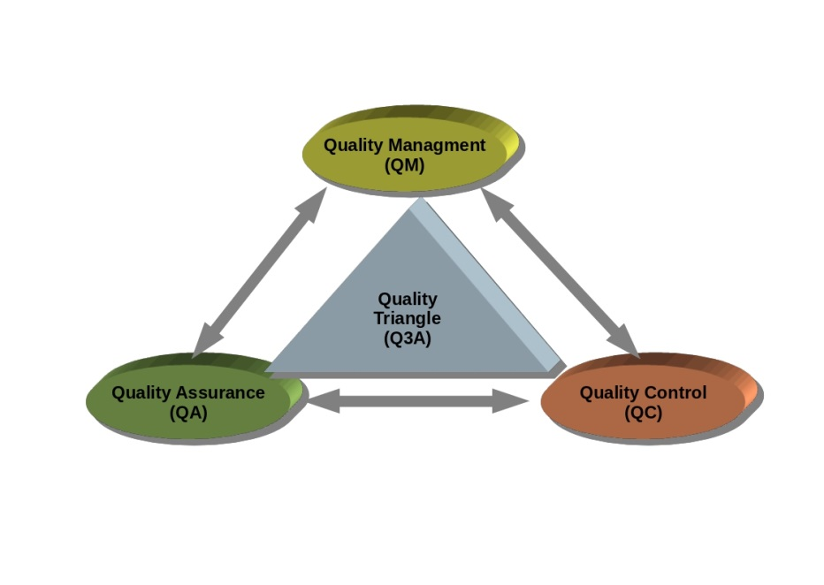
Figure 1: example for adding photos
Project Description:
This project introduces a smart online examination system composed of two integrated components:
- A web-based platform for students to take online exams.
- A mobile application for instructors and administrators to monitor exam sessions and manage suspicious activities in real time.
The student web platform provides a secure environment where students can log in, complete exams, and be monitored through AI-based detection modules.
The system incorporates advanced Artificial Intelligence techniques, including:
- Face recognition for identity verification.
- Gaze tracking to monitor attention and focus.
- Object detection to identify unauthorized devices (e.g., mobile phones).
- Audio analysis to detect suspicious background sounds.
The instructor/admin mobile application allows authorized users to:
- Monitor live exam sessions
- Receive real-time alerts about suspicious behavior.
- View flagged incidents with timestamps.
- Review risk reports for each student.
- Take actions such as warning, flagging, or reviewing recorded sessions.
This dual-platform architecture ensures centralized control while enabling flexible and efficient real-time monitoring.

Scope:
Methodology (Proposed Approach)
Phase/Module | Description
Authentication Phase | The student logs into the web platform using secure credentials.  The system performs face recognition to verify the student’s identity before allowing access to the exam.
Real-Time Monitoring | During the exam, multiple AI modules operate simultaneously, including:  Face tracking and gaze detection  Object detection (e.g., mobile phone detection using YOLO)  Audio classification to detect suspicious background sounds
RiskScoring Engine | All detected behaviors are analyzed and converted into a dynamic risk score.  If the risk score exceeds a predefined threshold, the system automatically generates an alert.
InstructorMobile Monitoring | The instructor receives real-time notifications through the mobile application.  Suspicious events are displayed with timestamps and detailed logs for review.
Reporting&Evaluation | After the exam session ends, the system generates a comprehensive behavioral report containing flagged events and risk analysis to support decision-making.

Deliverables

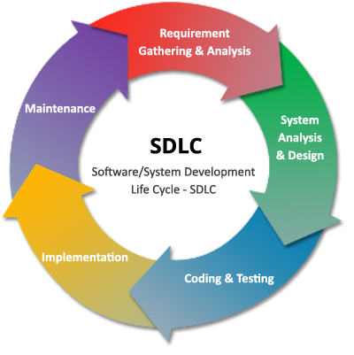
Figure 2: software development life cycle
Software Development Life Cycle (SDLC):
The development of the proposed smart online examination system followed the Software Development Life Cycle (SDLC) to ensure structured planning, systematic implementation, and continuous improvement. An iterative development approach was adopted to allow gradual refinement of system components and AI modules.
The project was completed through the following phases:
- Requirement Gathering & Analysis
In this phase, system requirements were collected and analyzed to clearly define the objectives and expected functionalities of the platform.
Key requirements included:
  - Secure student authentication.
  - Real-time AI-based monitoring.
  - Instructor/admin mobile application.
  - Risk scoring and alert generation.
  - Behavioral reporting system.
Both functional and non-functional requirements were defined to ensure performance, reliability, security, and scalability.
- System Analysis & Design
During this phase, the overall system architecture was designed.
  - The system was divided into two main components:
    - Web platform.
    - Mobile application.
  - AI monitoring modules were designed as independent components.
  - The database structure was created to store users, exam sessions, alerts, and reports.
  - UML diagrams such as Use Case Diagrams, Class Diagrams, and Sequence Diagrams were prepared to visualize system interactions.
- Coding & Testing
In this phase, the system was implemented using modern development technologies.
  - Development of the web platform (frontend and backend).
  - Development of the mobile monitoring application
  - Integration of AI models (face recognition, gaze tracking, object detection, audio analysis)
  - Unit testing and integration testing were conducted
  - AI detection accuracy was evaluated and optimized
- Implementation (Deployment)
After successful testing:
  - The system was deployed on a server environment.
  - The web platform was made accessible to students.
  - The mobile application was distributed to instructors.
  - Real-time communication and database connections were verified.
5. Maintenance
After deployment, continuous monitoring and maintenance were performed to:
  - Fix system bugs.
  - Improve AI model accuracy.
  - Enhance system performance.
  - Strengthen security measures.
This iterative process ensures long-term system reliability and scalability.

Summary
This chapter introduced the growing importance of online education and the challenges associated with maintaining academic integrity in remote examination environments. With the rapid expansion of digital learning platforms, online assessments have become widely adopted; however, they remain highly vulnerable to academic dishonesty due to the absence of direct physical supervision.
The chapter clearly defined the core problem: existing online proctoring systems suffer from high costs, privacy concerns, technological limitations, and vulnerability to bypass techniques. These weaknesses not only affect exam fairness but also impact institutional credibility, workforce quality, and the long-term sustainability of online education.
The importance of solving this problem was discussed from multiple perspectives, including protecting academic integrity, preserving trust in educational credentials, reducing financial burdens, and addressing ethical concerns related to invasive monitoring systems.
A review of current solutions highlighted their strengths and limitations, demonstrating the need for a more intelligent and comprehensive approach. In response, this chapter introduced the proposed smart online examination system, which integrates AI-based monitoring within a web platform for students and a mobile application for instructors and administrators.
Finally, the chapter outlined the project scope, methodology, system architecture, and the development process based on the Software Development Life Cycle (SDLC). This establishes a strong foundation for the detailed analysis, design, and implementation presented in the following chapters.

Chapter 2
Analysis and Design
Main points
- [give a brief abstract of your chapter here]

Introduction

User and System Requirements

Functional requirements

Non – functional requirements

Stack holders

System Design

Block Diagram
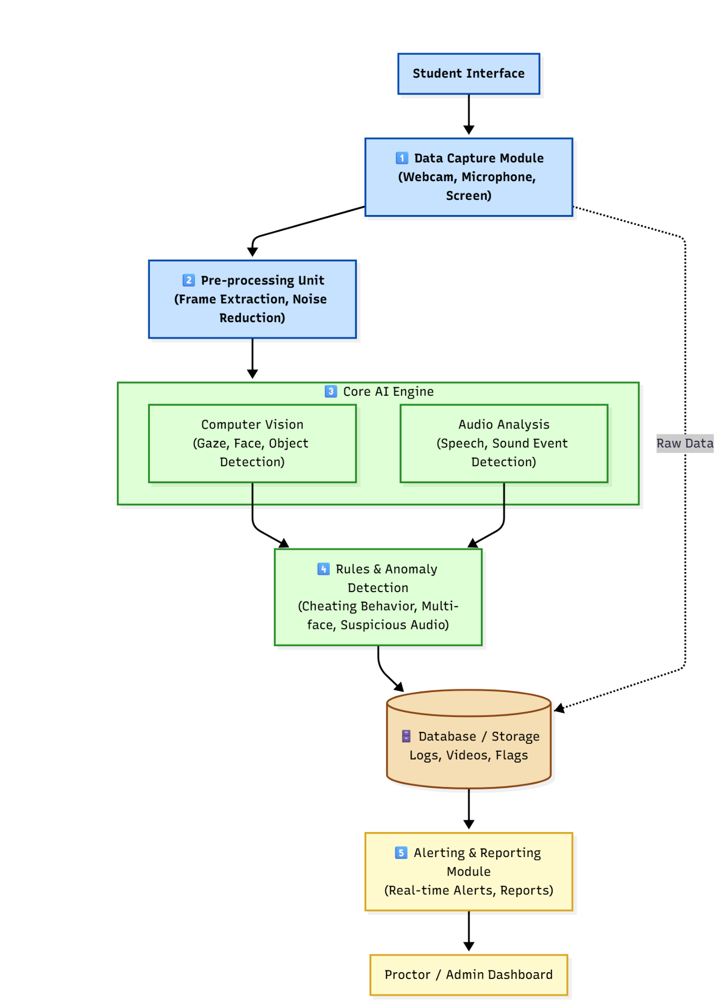

Use Cases

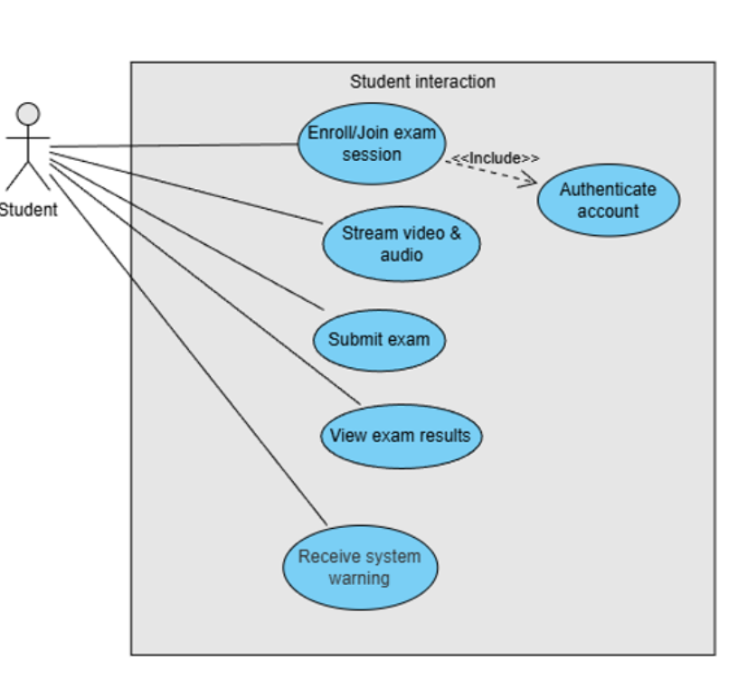.
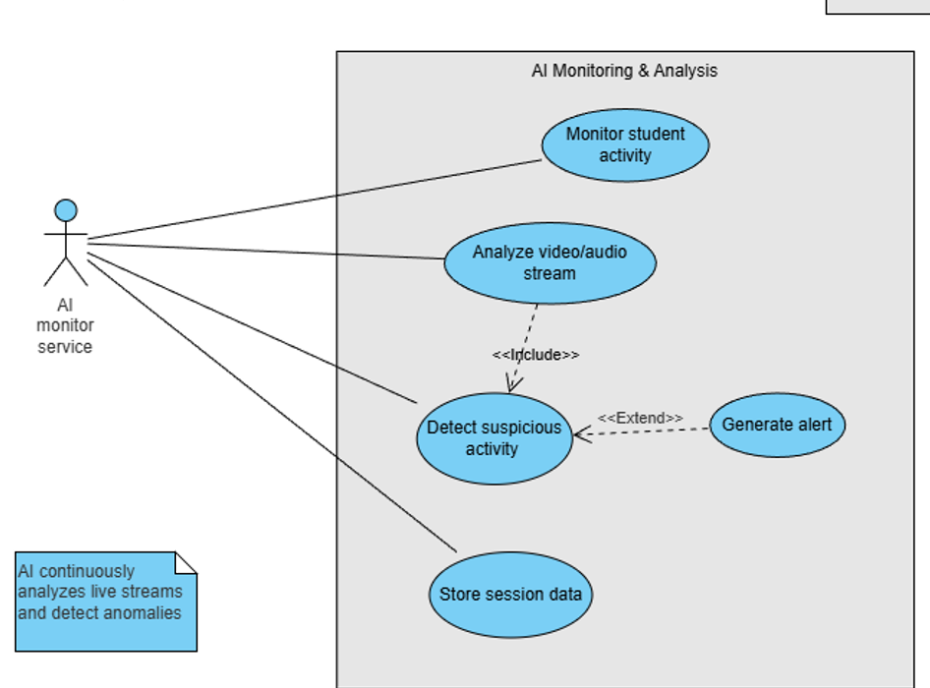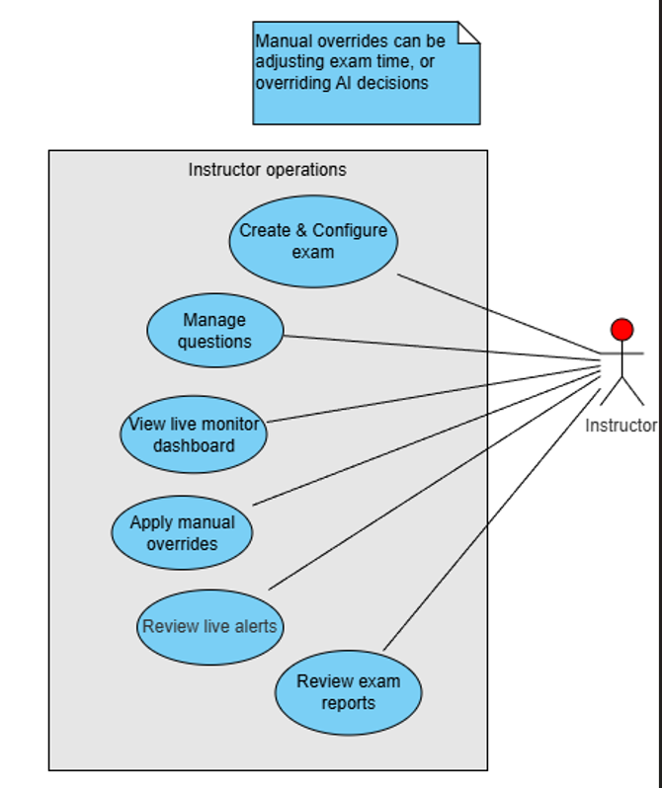

Class Diagram

Design Patterns

Sequence Diagrams

Database Design
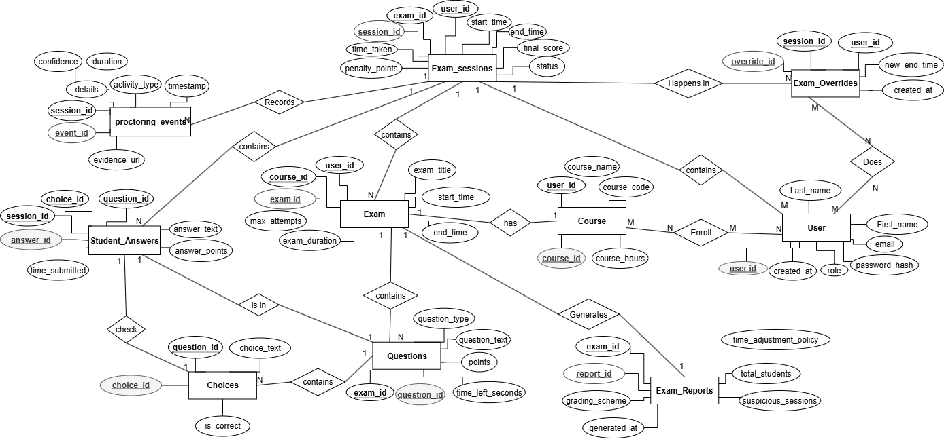

Used Technologies and tools

Summary

Chapter 3
Deliverables and Evaluation
Main points
- [give a brief abstract of your chapter here]

Introduction

User Manual

Testing

Evaluation (User experiment)

Summary

Chapter 4
Discussion and Conclusion
Main points
- [give a brief abstract of your chapter here]

Introduction
Lorem ipsum dolor sit amet, consectetuer adipiscing elit.

Figure 3

Main Findings

Why is this project important

Practical Implementations

Limitations

Future Recommendation

Conclusion Summary

References

